## horizontal line

Project Name

**Digital naturalist using IBM Watson Studio**

# INTRODUCTION

In our world, there are various species. Some species are being found rarely and if found also prediction becomes very difficult. In order to overcome this problem, we have an effective and simple way to recognize these species based on their features. Also, the human ability to recognize the birds through the images is more understandable than audio recognition. So, we have used Convolutional Neural Networks (CNN). CNN’s are the strong assemblage of machine learning which have proven efficient in image processing.

In this project, we are creating a web application which uses a deep learning model, trained on different species of birds, flowers and mammals and get the prediction of the bird when an image is being given.

# PROBLEM STATEMENT

A naturalist is someone who studies the patterns of nature, identifies a different kind of flora and fauna in nature. Being able to identify the flora and fauna around us often leads to an interest in protecting wild spaces, and collecting and sharing information about the species we see.

This project focuses on detection of different species of birds,flowers and mammals and obtaining images of that particular category (birds,flowers,mammals) when an image is given.

The app that we are developing would be very helpful to all the field naturalists as field naturalists can use this web app from anywhere to identify the birds, flowers, mammals and other species they see on their hikes, canoe trips and other excursions.

**SOLUTION**

The solution offered for this problem statement is the development of a web classification application, which analyzes the input images of various species and accurately determines the image of that category . Convolutional neural networks (CNN) implemented using necessary python libraries on IBM Watson Studio and Jupyter Notebook can be used to develop the model required to classify the images of species. Flask is used to integrate the deep learning model with a web user interface.

**LITERATURE SURVEY**

In particular, it was discovered that ecologists monitor them to determine the factors causing population fluctuation and to help in conserving and managing threatened and endangered species. The various surveys used in counting species including data collection techniques were succinctly reviewed. It was established that a small but growing number of researchers have studied the use of computer vision for monitoring species.

John Martinsson et al (2017), presented the CNN algorithm and deep residual neural networks to detect an image in two ways i.e., based on feature extraction and signal classification. They did an experimental analysis for datasets consisting of different images. But their work didn’t consider the background species. In Order to identify the background species larger volumes of training data are required, which may not be available.

Juha Niemi, Juha T Tanttu et al (2018) , proposed a Convolutional neural network trained with deep learning algorithms for image classification. It also proposed a data augmentation method in which images are converted and rotated in accordance with the desired color. The final identification is based on a fusion of parameters provided by the radar and predictions of the image classifier

Madhuri A. Tayal, Atharva Magrulkar et al (2018)[4], developed a software application that is used to simplify the species identification process. This species identification software takes an image as an input and gives the identity of the species as an output. The technology used is transfer learning and MATLAB for the identification process.

**FLOW OF THE SYSTEM**

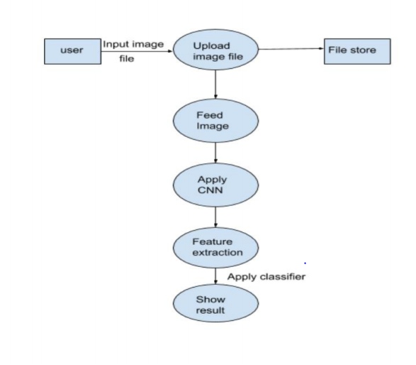

**EXPERIMENTAL ANALYSIS**

The evaluation of the proposed approach for species classification by considering color features and parameters such as size, shape, etc. of the bird on the dataset

This is an image dataset annotated with

In this the project training of dataset is done by using google colab, which is a platform to train dataset by uploading the images from your local machine or from the Google drive.

After training, the labeled dataset is ready for classifiers for image processing.

**HARDWARE AND SOFTWARE REQUIREMENTS**

**Tools used:** Jupyter notebook,IBM Watson studio

**Programming language**: Python

**Necessary modules**: Tensorflow,Keras

**Tensorflow:**

It is an open-source toolkit that can be used for building machine learning pipelines so that you can build scalable systems to process data. It provides support and functions for various applications of ML such as Computer Vision, NLP and Reinforcement Learning. TensorFlow is one of the must-know tools of Machine Learning for beginners.

**Keras:**

Keras is an open-source neural network library that provides support for Python. It is popular for its modularity, speed, and ease of use. Therefore, it can be used for fast experimentation as well as rapid prototyping. It provides support for the implementation of convolutional neural networks, Recurrent Neural Networks as well as both.

**RESULTS**

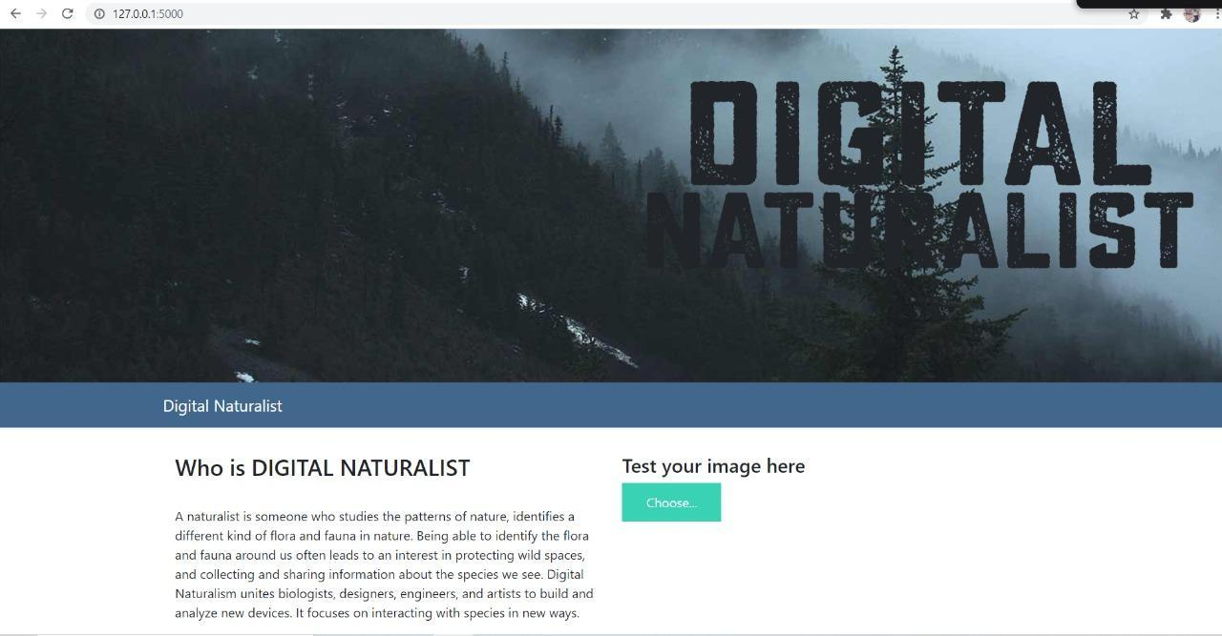

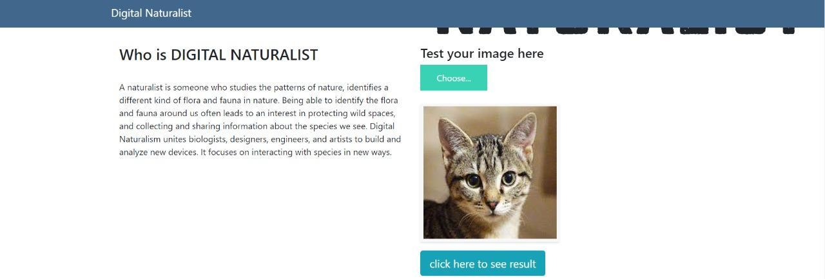

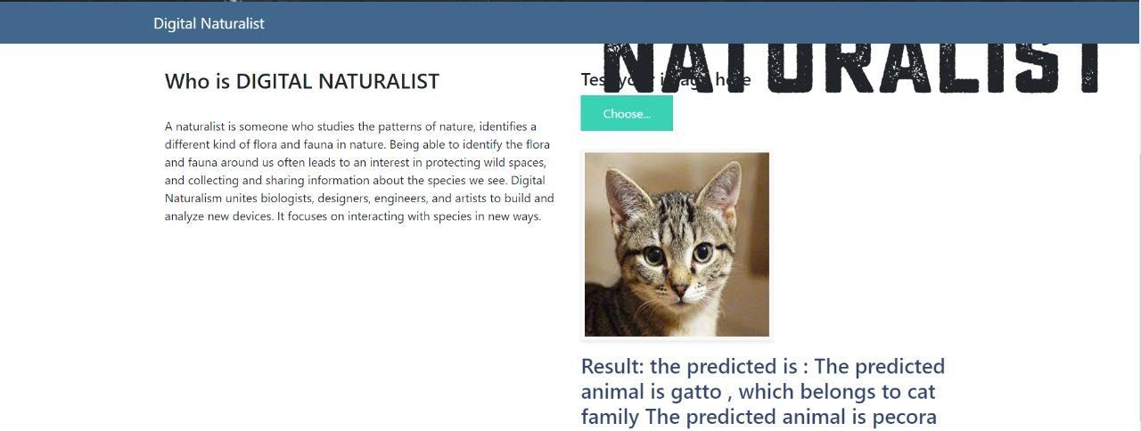

**CONCLUSION**

The main idea behind developing the identification website is to build awareness regarding the identification of species. It also caters to the need of simplifying the bird identification process and thus making identification easier. The technology used in the experimental setup is Convolutional Neural Networks (CNN). It uses feature extraction for image recognition. The method used is good enough to extract features and classify images.

**FUTURE WORK**

System can be implemented using the cloud which can store large amount of data for comparison and provide high computing power for processing (in case of Neural Networks).